Cards: Taxonomy Profile
Taxonomy Factor | Classification
Name | Online card games. Representative title: Zynga Poker (Texas Hold'em). Real-money variants: skill-cash solitaire (e.g., Solitaire Cash) and online poker, rummy, and Teen Patti apps
Candidate Class | Social-casino apps (free-to-play, purchasable chips), with real-money card variants at the far end of the cash-realisability scale
Primary Audience | Adults. The Google Play listing describes Zynga Poker as intended for adults; no age check was tested. Real-money variants target adult depositors
Gambling Connection | High. Social variants simulate poker with chance-driven chips and no cash-out; real-money variants are direct gambling or gambling-adjacent contests
Addiction / Harm Score | 7/10: High
Risk Score | 7/10: High
Tier Classification | T2: paid random draw, no cash-out (Zynga Poker). Real-money variants: T4/T5 boundary (skill-cash solitaire); T6 (unlicensed real-money poker in Australia, and online money games banned in India)
Financial Score | 7/10: High
Monetary Value | Social variants: purchased chips, closed-loop, no cash-out route identified. Real-money variants: cash deposit in, cash prize or winnings out
Regulatory Status | Zynga Poker: no gambling licence identified; the App Store lists frequent simulated gambling (Apple, n.d.), and Australia requires R18+ for simulated gambling (Australian Classification Board, 2024; compliance not checked). Real-money variants: online money games are prohibited in India since 1 May 2026 (Lexology, 2026; Press Information Bureau, 2026), and the Australian Communications and Media Authority (ACMA) has blocked unlicensed offshore poker sites (e.g. CoinPoker, June 2025; Gambling Insider, 2025). Papaya settled a US$15M player class action over alleged undisclosed bots without admitting wrongdoing (ClassAction.org, 2025); separately, a federal jury found in April 2026 that Papaya misrepresented its games as skill-based while using bots, and a US$719M judgment was entered in July 2026 (Perkins Coie, 2026; Takahashi, 2026).

1. Cards
"Cards" covers online games played with a standard deck, and it includes three kinds of products. Zynga Poker is a free-to-download Texas Hold'em app with tables, tournaments, a Challenge Pass, and a VIP programme (Apple, n.d.). Alongside it are skill-cash solitaire apps such as Papaya Gaming's Solitaire Cash, and real-money poker, rummy, and Teen Patti apps. Zynga Poker's core function is play, not payout, but the other two kinds take real money and pay real money out.

2. Description and Connection to Gambling
The three variants differ sharply in cash-realisability. Zynga Poker lets players wager virtual chips and buy random items (Apple, n.d.; Google, n.d.). Its Google Play listing describes it as intended for adults with no chance to win real money, while Apple labels it as containing frequent simulated gambling. Skill-cash solitaire, such as Solitaire Cash, requires cash deposits and offers contests with prizes that winners can withdraw (ClassAction.org, 2025). Skillz states that these contests should not be considered gambling because the results depend on skill instead of chance (Skillz, n.d.). However, this represents the platform’s own position rather than a decision made by a legal authority. Real-money poker, rummy, and Teen Patti apps are generally understood as gambling because participants stake funds for the possibility of receiving cash.
The gambling connection is thus a continuum, with the first variant as simulated, the second as contested, and the third as direct. In all three, there are chips or tokens in between the player and their money, and these are the loss-concealing mechanisms in the present study. According to a scoping review of experiments using monetary format, the evidence base is thin and inconsistent (Palmer et al., 2022), while pilot evidence suggests that players wager more with chips than with equivalent cash (Lapuz & Griffiths, 2010).
Gambling Connection: High (simulated to direct).

3. Age Group and Addiction Risk
Primary age group: Adults. Listings place Zynga Poker as an adult product. Although an age check was not tested within the app, a 2015 Australian review indicated that the simulated gambling was unsuitable for younger players (Children and Media Australia, 2015). Australia now has a rating of R18+ for simulated gambling and at least M for paid chance-based purchases (Australian Classification Board, 2024), although a 2025 preprint identified large proportions of top games given unsuitable ratings (Carter et al., 2025).
Addiction / Harm Score: 7/10: High. Documented mechanics:
- Chip-based betting on outcomes involving chance. Poker hands are wagered in the form of chips that are purchased, won, or given as gifts, thus making it feel like the money is not being spent.
- Free-chip bonuses. According to the App Store description, there is a very large welcome chip bonus and daily bonuses (Apple, n.d.), a form of temporal dark pattern described by Zagal et al. (2013) as encouraging return visits.
- Progression passes and a VIP programme with respect to special chip packages (Apple, n.d.).
- Random purchasable items. The listing reveals that some purchases provide chance-selected contents and refers players to in-game drop rates.
In one subsample of the survey, 176 adults who played social casino games and reported gambling problems showed that more frequent, more varied, and larger amounts spent on playing those games were linked to more symptoms of problematic use, with playing to escape a negative mood being the most prevalent symptom (Gainsbury et al., 2017). This is a taxonomy evaluation based on published studies and is not a clinical diagnosis.

4. Risk or Danger
Risk Level: High: 7/10.
- Contests involving concealed automated opponents. Without admitting fault, a settlement of US$15M was announced by Papaya Gaming to settle a player class action lawsuit for allegedly running hidden bots in games such as Solitaire Cash while presenting them as skill-based contests (ClassAction.org, 2025). On 23 April 2026, a New York jury found that Papaya misrepresented its games as fair competitions between real players while using bots, and awarded US$420 million in damages (Perkins Coie, 2026). The court later substituted US$719 million in disgorgement for the jury’s award and added approximately US$10 million in fees when judgment was entered on 28 July 2026 (Regulatory Oversight, 2026). Papaya stated that it was considering an appeal (Takahashi, 2026). One law-firm commentary reports a higher overall total, so the court docket should be consulted before using the number. The settlement did not include findings, but the verdict did: a “skill” label does not mean that it is a fair contest.
- Legal risk for online money games in India. The Promotion and Regulation of Online Gaming Act 2025 bars online money games, including those that rely on skill or chance, such as real-money rummy and poker (International Masters of Gaming Law [IMGL], 2026; Promotion and Regulation of Online Gaming Act 2025), and extends to services provided from abroad (Lexology, 2025).
- Offshore real-money poker in Australia. The ACMA requested internet service providers to block unlicensed sites, such as the poker site CoinPoker in June 2025 (Gambling Insider, 2025), and has cautioned that illegal sites are unlikely to provide important consumer safeguards despite appearing legitimate (ACMA, 2024).
Zynga Poker itself sits at the low end of this group because no cash-out route exists. The higher risk score comes from the real-money variants that share the "cards" label.

5. Tier Classification
Tier: T2 for Zynga Poker; T4 to T6 for real-money variants.
Classification path (Zynga Poker):
Zynga Poker → purchased or free chips → chance-based card play and random items → chip balance → no cash-out route → T2
Classification path (skill-cash solitaire):
Solitaire Cash-style app → cash entry fee → skill contest → cash prize → T4/T5 boundary (paid and cashable, but a skill contest rather than licensed wagering)
Classification path (offshore poker, rummy, Teen Patti):
Real-money table → cash deposit → cash withdrawal → T6 in Australia (no Australian licence) and a prohibited online money game in India
Note for the taxonomy: "cards" is a game-type facet. The tier depends on the variant, and the skill-cash case needs a supervisor rule on whether it is T4 or T5. The bots theory in the federal case (Perkins Coie, 2026) is a further reason not to place skill-cash apps in T4 or T5 on the "skill" label alone.

6. Harm: Financial Harm and Psychological Harm
Financial Score: 7/10: High
Financial harm. In social variants, money spent on chips cannot be recovered, so each purchase is a pure cost. Real-money variants add direct loss of deposits, with no dispute route where the operator is unlicensed (ACMA, 2024). Langham et al. (2016) identify financial harm as one of seven categories of gambling-related harm and find that harm is not confined to people who meet diagnostic criteria.
Psychological harm. Playing to escape a negative mood is the leading reported symptom among at-risk social-casino players, and younger, less educated and more distressed gamblers reported greater problems (Gainsbury et al., 2017). That places emotional and psychological harm, another of Langham et al.'s (2016) categories, at the centre of this profile.

7. Monetary Value
Monetary Value: Closed-loop chips (social variant); real cash in and out (real-money variants)
Cash-out pathways:
- Zynga Poker: money → chips → wagers → chip balance. No route to cash was identified in the store listings.
- Skill-cash solitaire: cash deposit → cash contest → cash winnings paid to winners (ClassAction.org, 2025). Whether outcomes are genuinely skill-determined is contested (see Section 4).
- Offshore poker, rummy and Teen Patti: deposit → real-money table → cash withdrawal at the operator's discretion, outside Australian or Indian consumer protection.

8. Evidence as Images
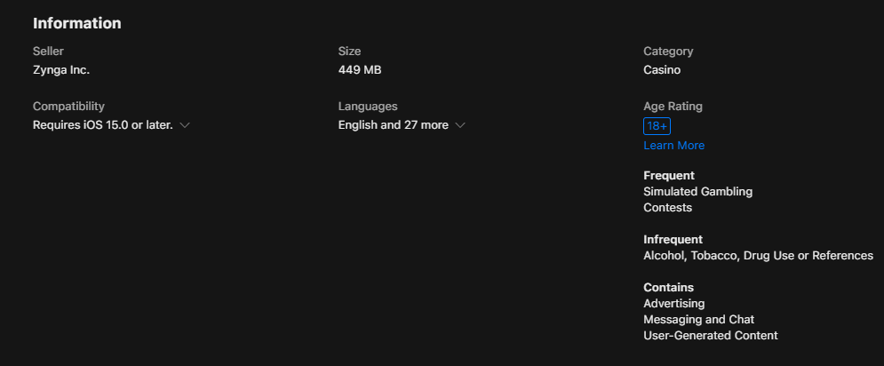 | 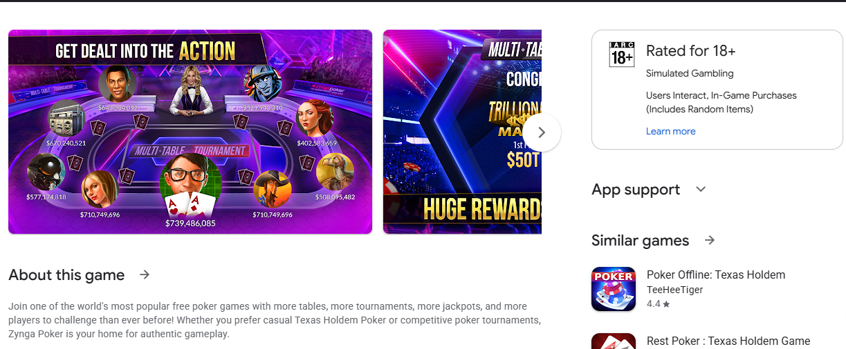
Figure 1: Zynga Poker App Store information panel showing an 18+ age rating and frequent simulated gambling and contests labels | Figure 2: Zynga Poker Google Play listing showing an 18+ rating with simulated gambling and in-game purchase (random items) descriptors
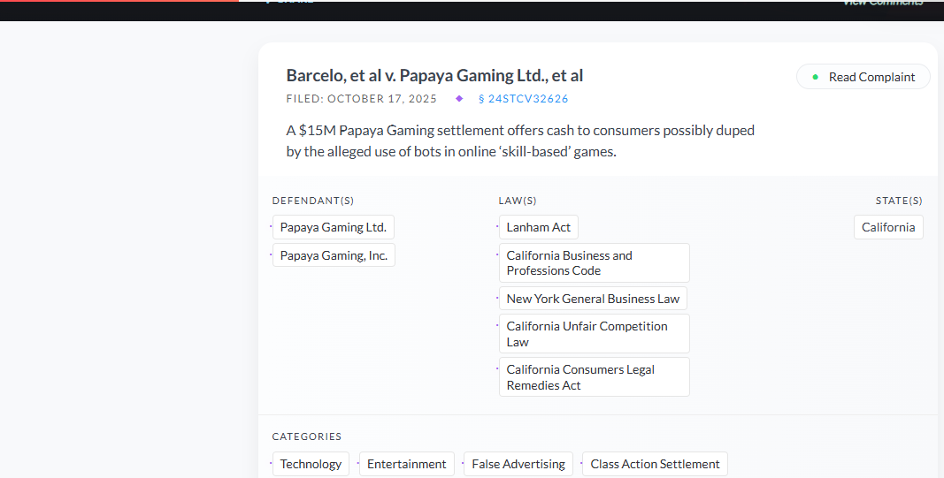 | 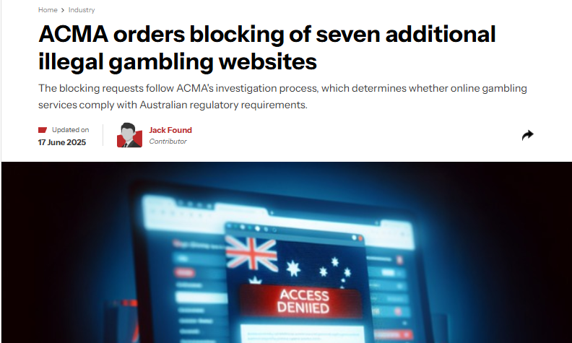
Figure 3: ClassAction.org page for the Papaya Gaming settlement (Barcelo v. Papaya Gaming), alleging bots in "skill-based" games | Figure 4: Gambling Insider report of the ACMA blocking request, dated 17 June 2025

9. References
Apple. (n.d.). Zynga Poker: Texas Hold'em [App Store listing]. Retrieved 21 September 2026, from https://apps.apple.com/us/app/zynga-poker-texas-holdem/id354902315
Australian Classification Board. (2024). New classifications for gambling-like content in video games. https://www.classification.gov.au/about-us/media-and-news/news/new-classifications-for-gambling-content-video-games
Australian Communications and Media Authority. (2024, May). ACMA blocks more illegal gambling websites. https://www.acma.gov.au/articles/2024-05/acma-blocks-more-illegal-gambling-websites
Carter, M., Zhangshao, T., Hardwick, T., Egliston, B., & Xiao, L. Y. (2025). Investigating mobile games' compliance with Australia's 2024 mandatory minimum age classifications scheme for gambling-like mechanics [Preprint]. SSRN. https://doi.org/10.2139/ssrn.5543999
Children and Media Australia. (2015, February 25). App review of Zynga Poker Classic TX Holdem. https://childrenandmedia.org.au/app-reviews/apps/zynga-poker-classic-tx-holdem
ClassAction.org. (2025, November 20). $15M Papaya Gaming settlement ends class action over alleged use of bots in "skill-based" contests. https://www.classaction.org/news/15m-papaya-gaming-settlement-ends-class-action-over-alleged-use-of-bots-in-skill-based-contests
Gainsbury, S. M., King, D. L., Russell, A. M. T., Delfabbro, P., & Hing, N. (2017). Virtual addictions: An examination of problematic social casino game use among at-risk gamblers. Addictive Behaviors, 64, 334–339. https://doi.org/10.1016/j.addbeh.2015.12.007
Gambling Insider. (2025, June 17). ACMA orders blocking of seven additional illegal gambling websites. https://www.gamblinginsider.com/news/29880/acma-orders-blocking-of-seven-additional-illegal-gambling-websites
Google. (n.d.). Zynga Poker – Texas Holdem Game [Google Play listing]. Retrieved 21 September 2026, from https://play.google.com/store/apps/details?id=com.zynga.livepoker&hl=en_US
International Masters of Gaming Law. (2026). What India's new regulations mean for online gaming. IMGL Magazine, 3(1). https://www.imgl.org/publications/imgl-magazine-volume-3-no-1/what-indias-new-regulations-mean-for-online-gaming/
Langham, E., Thorne, H., Browne, M., Donaldson, P., Rose, J., & Rockloff, M. (2016). Understanding gambling related harm: A proposed definition, conceptual framework, and taxonomy of harms. BMC Public Health, 16, Article 80. https://doi.org/10.1186/s12889-016-2747-0
Lapuz, J., & Griffiths, M. D. (2010). The role of chips in poker gambling: An empirical pilot study. Gambling Research, 22(1), 34–39.
Lexology. (2025, September 1). Behind the ban: The Promotion and Regulation of Online Gaming Act, 2025. https://www.lexology.com/library/detail.aspx?g=67f5157a-fefc-4836-9f9f-97987c0174da
Lexology. (2026, May 6). Setting the rules of the game: India's online gaming law comes into force. https://www.lexology.com/library/detail.aspx?g=29103459-cefe-4528-a762-dbd53ce6979e
Palmer, L., Cringle, N., & Clark, L. (2022). A scoping review of experimental manipulations examining the impact of monetary format on gambling behaviour. International Gambling Studies, 22(3), 499–521. https://doi.org/10.1080/14459795.2022.2041067
Perkins Coie. (2026, June 17). Skillz v. Papaya Gaming: Record Lanham Act verdict puts bots, matchmaking, and "skill-based" marketing on trial. https://perkinscoie.com/insights/update/skillz-v-papaya-gaming-record-lanham-act-verdict-puts-bots-matchmaking-and-skill
Press Information Bureau. (2026). Promotion and Regulation of Online Gaming Rules, 2026 [Press release]. https://www.pib.gov.in/PressReleasePage.aspx?PRID=2256973&reg=3&lang=2
Promotion and Regulation of Online Gaming Act 2025 (India). Ministry of Electronics and Information Technology. https://www.meity.gov.in/static/uploads/2025/10/8a7f103cefc68ed8aaa2ebc9a2ed7c13.pdf
Regulatory Oversight. (2026, July 31). When "skill-based" isn't: The Papaya Gaming verdict and its implications for mobile gaming operators. https://www.regulatoryoversight.com/2026/07/when-skill-based-isnt-the-papaya-gaming-verdict-and-its-implications-for-mobile-gaming-operators/
Skillz. (n.d.). The legality of skill gaming [Vendor documentation]. https://docs.skillz.com/docs/legal-skillz/
Takahashi, D. (2026, July 28). Skillz (now Firy) wins $719M judgment against Papaya Gaming in largest false advertising award in history. GamesBeat. https://gamesbeat.com/skillz-now-firy-wins-719m-judgment-against-papaya-gaming-in-largest-false-advertising-award-in-history/
Zagal, J. P., Björk, S., & Lewis, C. (2013). Dark patterns in the design of games. In Proceedings of the 8th International Conference on the Foundations of Digital Games.

